Every triangle has 3 angles and 3 sides. Given any 3 quantities out of 3 angles and 3 sides (at least one of which is a side) are given then remaining 3 can be found , which is termed as solution of the triangle. Many interesting relation among these quantities will be discussed in this section. Which formula is to be used where is a very important point here, as a use of wrong formula might lead to large calculations. So be prepared to see some very interesting stuff.

Terminology
Side AB , BC, CA of a ΔABC are denoted by c, a, b respectively and is semi perimeter of the triangle and Δ denotes area of the triangle.
Since Rule:
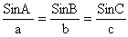

How?
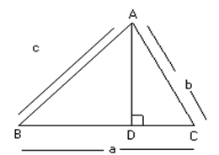
Fig (1)
Draw AD perpendicular to opposite side meeting it in point D.
In ΔABD,
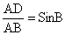
⇒ AD = cSinB
In Δ ACD,
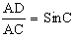
⇒ AD = bSinC
Equating 2 values of AD we get
cSinB = bSinc
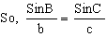
Similarly drawing a perpendicular line from B upon CA we have
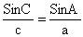
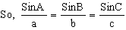
Illustration 1:
Given that ∠B=30, C=10 and b=5 find the angles of A and C of triangle.
Ans:
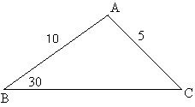
Fig (3)

By using sine rule,
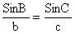
Cosine Rule:
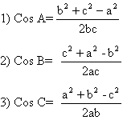

How?
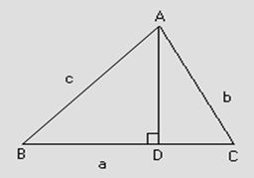

Fig (4)
Let ABC be a triangle and let perpendicular from A on BC meet it in point D
Now AB²= AD²+BD²
= (BC-CD) ²+ (AC²-DC²)
= BC²+CD²-2BC.CD+AC²-DC²
= AC²+BC²-2BC.CD ------------------ (1)
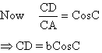
So, equation (1) is now
c² = b²+a²-2abCosC
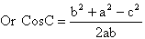
Similarly CosA, CosB can be found.
Illustration 2:
Show that the triangle is obtuse angled when sides of triangle 3x+4y, 4x+3y, 5x+5y units where x, y>0.
Ans:
Let a= 3x+4y
b= 4x+3y
c= 5x+5y
Since x, y>0 so c is largest side and angle C will be largest angle.
So,
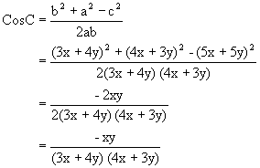
Now since x, y>0
So, Cos C<0
And thus angle C is obtuse.
Projection Formula:
1) a = bCosC + cCosB
2) b = cCosA + aCosC
3) c = aCosB + bCosA
How?
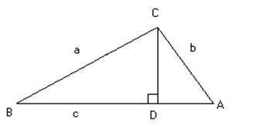
Fig (5)
Let us draw a perpendicular line from C on Side AB
So, AB=BD+AD
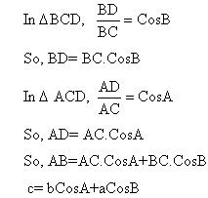
Illustration 3:
Drive Projection formula using the Cosine Rule
Ans:
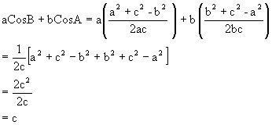

Napier Analogy:
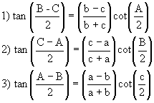

How?
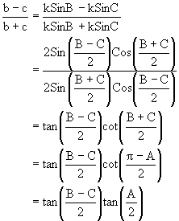
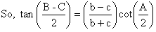

Illustration 4:
If in a triangle ABC, a = 6, b = 3, and Cos (A-B) = 4/5 then find the angle C.
Ans:
Cos (A-B) = 4/5
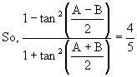
Componendo and dividendo:
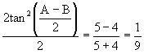
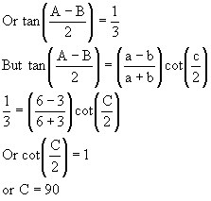
Trigonometric ratios of half angles:
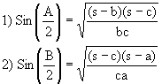
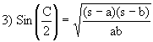
How?
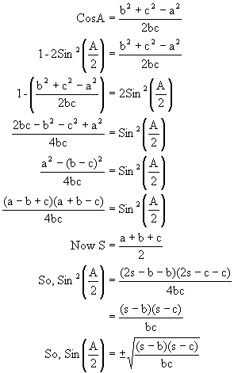
Since A is angle of triangle, so 0<A<180 and thus A/2 is acute.
So, Sin A/2 has to be +ve and thus 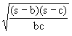

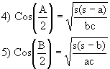
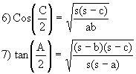
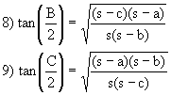
Area of Triangle ABC:
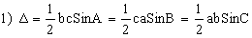
How?
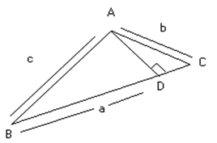
Fig (6)
Let there be a triangle ABC and draw a perpendicular AD on the side BC from A
So, now Δ = ½ AD.BC.
In triangle ABD
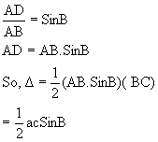
Why?

Solution:
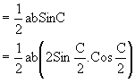
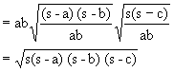
m-n theorem

If in a triangle ABC, point D divides BC in the ratio m: n and ∠ADC =Q then,

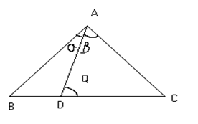
Fig (7)
1) (m+n) CotQ = mCotα-nCotβ

2) (m+n) CotQ= nCotβ-mCotC

Illustration 5:
Find the value of y in
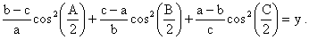?
Ans:
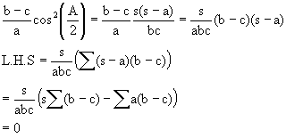
So, y = 0.

CIRCUMCIRCLE:
The Circle passing through points A, B, C of a triangle ABC, its radius is denoted by R.
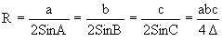

How?
Bisect the 2 side BC and AC in D and E respectively and draw DO and EO perpendicular to BC and CA
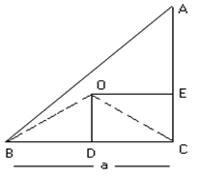
Fig (8)
So, O is center of circumcircle.
Now ΔBOD ≅ΔDOC (By RHS congruency rule)
So, ∠BOD = ∠DOC
= ½ ∠BOC
= ∠BAC
= ∠A
Now, in ΔBOD, BD = BO Sin (∠BOD)
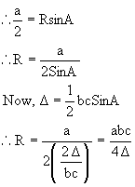
Illustration 6:
If in the ΔABC, O is circumcenter and R is the circumradius and R₁, R₂, R₃, are circumradii of the triangle OBC, OCA, OAB respectively then prove that
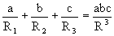
Ans:

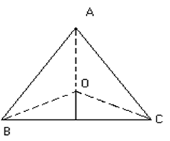
Fig (9)
Clearly in Δ OBC, ∠BOC = 2A, OB = OC = R, BC = a
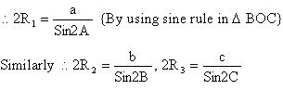
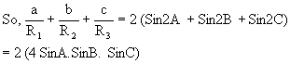
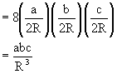

Incircle:
The Circle which touches all the sides of ΔABC internally its radius is denoted by r.
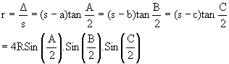
How?
Bisect the ∠B and ∠C by line BI and CI meeting in I
So now I is in center of the circle. Draw ID, IE and IF ⊥ to 3 sides.
So, ID = IE = IF = r
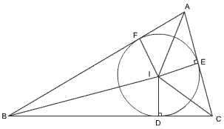
Fig (10)
Now we have
Area of ΔIBC = ½ ID.BC= ½ r.a
Area of ΔIAC = ½ IE.AC= ½ r.b
Area of ΔIAB = ½ IF.AB= ½ r.c
Area of ΔABC= area of ΔIBC + area of ΔIAC + area of ΔIAB.
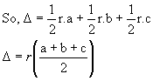

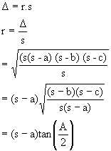
Now what about r = 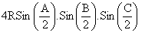
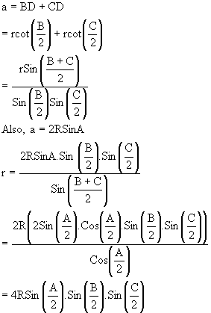

Illustration7:
A, B, C are the angles of a triangle, prove that:
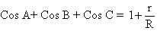

Ans:
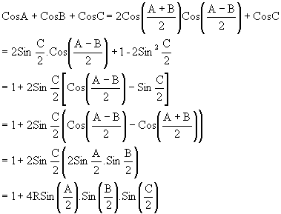
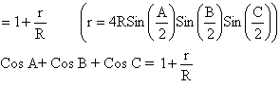
Excircles or Escribed circles:
The circle which touch BC and the two sides AB and AC produced is called escribed circle. Opposite the angle A and its radius is denoted by r₁. Similarly radii of circle opposite the angle B and C are denoted by r₂ and r₃ respectively.
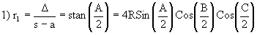
How?
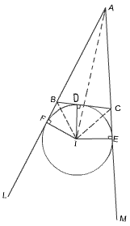
Fig (11)
Produce AB and AC to L and M. Bisect ∠CBL and ∠BCM by lines BI and CI and, let these lines meet in I.
Draw ID, IE, IF ⊥ to 3 sides respectively.
I is center of the escribed circle and so ID=IF=IE=r₁.
Now area of ΔABC + area of ΔIBC = area of ΔIAB + area of ΔIAC
So, Δ+ ½ (ID) (BC) = ½ (IF) (AB) + ½ (IE) (AC)
⇒ Δ + ½ r₁a = ½ r₁c + ½ r₁b
So, Δ = ½ r₁ (b+c-a)
= ½ r₁ ((a+b+c)-2a)
= ½ r₁ (2s-2a)
= r₁ (s-a)
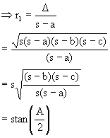
Now what about 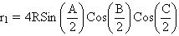
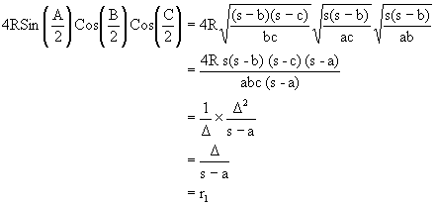

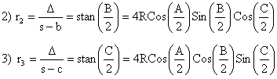
Illustration 8:
Show that 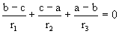
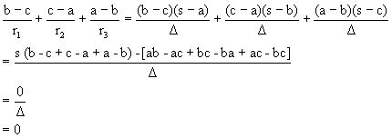
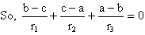

Orthocenter and Pedal Δ:
Let ABC be any triangle and let AD, BE and CF be the altitudes of ΔABC. Then the ΔDEF formed by joining point D, E and F the feet of ⊥ is called the pedal Δ of ΔABC.

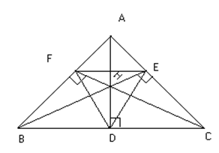
Fig (12)
Now
1) AH = 2RCosA, BH = 2RCosB, CH = 2CosC
How?
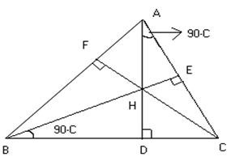

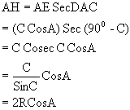
2) HD = 2R CosB CosC, HE = 2R CosA CosC, HF = 2R CosA CosB
Why?
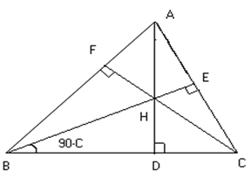
Fig (14)
HD = BD tan ∠HBD
= BD tan (90⁰ - c)
= AB CosB.CotC
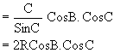
Illustration 9:
Prove that centroid, orthocenter and circumcenter of a Δ are collinear and centroid divides the line joining orthocenter and circumcenter in ratio 2:1.
Ans:
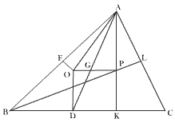
Fig (15)
Let O and P be circumcenter and orthocenter respectively. Draw OD and PK ⊥ to BC.
Let AD and OP meet in G.
Now the ΔAGP and ΔDGO are equiangular which is clearly due to the fact that OD and PK are parallel lines.
Now OD = OB Cos ∠BOD
= OB CosA
= RCosA
Also AP = 2RCosA
So, by similar triangles,
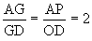
So, point G is centroid of the Δ
Again by the same proposition
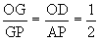
So, centroid divides line joining circumcenter to orthocenter in ratio 1:2.
Bisectors of theangles:
If AD is the angle bisector of ∠A then AD 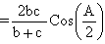
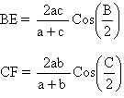

How?
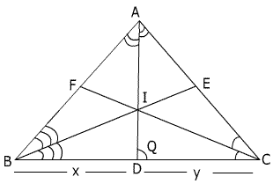
Fig (16)
Now area of ΔABD + area of ΔADC = area of ΔABC
⇒ ½ AB.AD Sin (A/2) + ½ AC.AD Sin (A/2) = ½ AB.AC SinA
⇒ AD (AB Sin (A/2) + AC Sin (A/2)) = AB.AC.2Sin (A/2) Cos (A/2)
⇒ AD (b+c) = 2bc Cos (A/2)
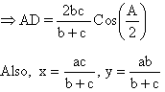

How?
Now in ΔABD
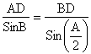
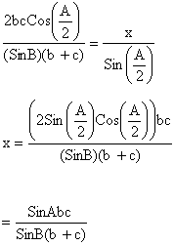
Now by using sine rule.
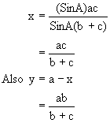

Medians:

If AD is a median then
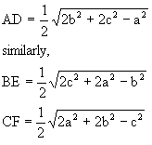
How?
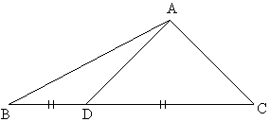
Fig (17)
In ΔADC use cosine law
So AD² = AC²+DC²-2AC.DC.CosC
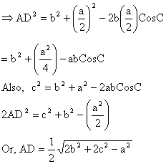

Illustration 10
In a ΔABC prove that 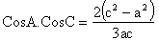 where AD is the median through A and
AD⊥AC
Ans:
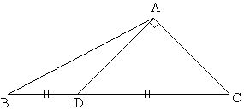
Fig (18)

In ΔADC
AD² = DC²-AC²
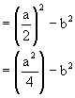
But
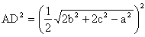
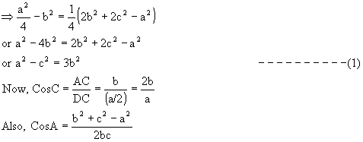
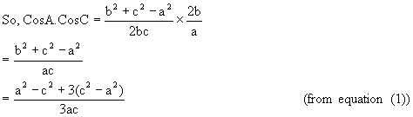
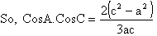
Solution of triangles
When any 3 of the 6 elements (except all 3 angles) of a Δ given, the triangle is completely known. This process is called solution of triangle.
Case 1: When the sides a, b, c are given then how to find?
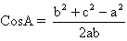
Similarly B and C can be obtained.

Case 2: When two side’s b, c and included angle A are given then how to find?
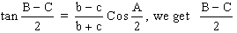
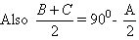 So, B and C can be evaluated.
The third side is given by a 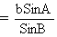
Case 3: When 2 sides’ b and c and angle B (opposite to side b) are given
1) If angle B is acute.
a. No triangle possible if b<cSinB
b. One right angled Δ, right angled at C if b=cSinB
c. two Δ’s are possible if cSinB<b<c

How?
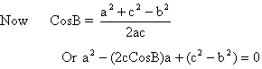
So, for real values of a
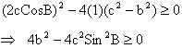
∴ If b<cSinB no triangle is possible.
Now if b=cSinB
Then 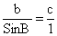
So, a right angle triangle with angle c= 90⁰ is possible
Now,
Is positive (B is acute)
But if is also be positive
Then
Or c²>b²
Or c>b,
So, if CSinB<b<c
Then 2Δ’s are possible.
2) If ∠B is obtuse: only one Δ is possible if b>c

How?
CosB= 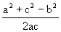
Or
a =
Since B is obtuse CosB<0
So, a cannot be as it is less than zero.
So, only possibility is a = but this will be
Positive only if
Or c²<b²
Or c<b so, one Δ is possible if b>c.

Q-3: If p, q are perpendiculars from the angular points A and B of the ΔABC drawn to any line
Through the vertex C then prove that
Solution:
Let ∠ACE = α clearly from fig we get

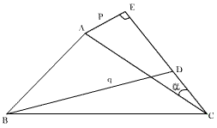
Fig (21)
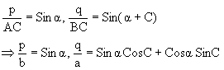
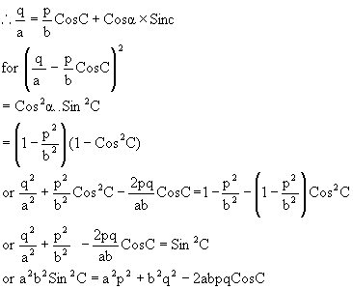

Q-4: Find the expression for area of cyclic quadrilateral.
Solution: A quadrilateral is cyclic quadrilateral if its vertices lie on a circle.
Let ABCD be a cyclic quadrilateral such that AB=a, BC=b, CD=c and DA=d.
Then ∠B+∠D = 180 and ∠A+∠C = 180
Let 2s = a+b+c+d be the perimeter of the quadrilateral.
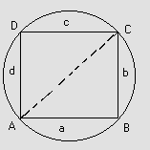
Fig (22)
Now, Δ = area of cyclic quadrilateral ABCD
= area of ΔABC + area of ΔACD
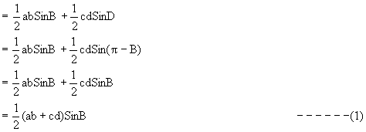
Using Cosine formula in a triangle ABC and ACD we have
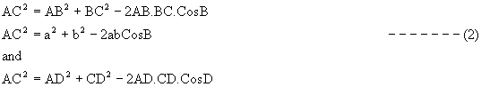
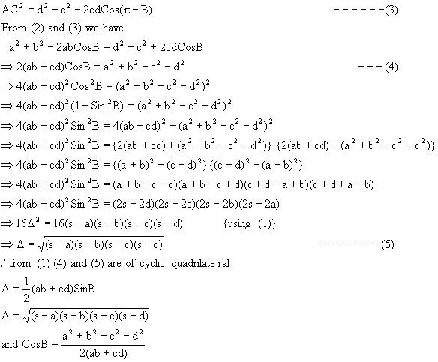

Q-5: Find the distance between the circumcenter and incenter.
Solution:
Let O be the circumcenter and I be the incenter of ΔABC. Let OF be perpendicular to AB and IE be perpendicular to AC and ∠OAF = 90-C.
∴∠OAI = ∠IAF-∠OAF
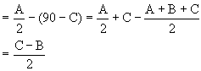
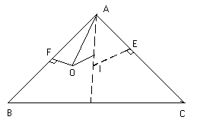
Fig (23)
Also,
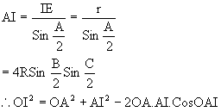
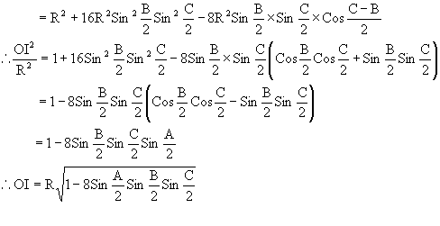
Q-6: Prove that Where r = inradius, R=circum radius r₁, r₂, r₃ are exradii.
Solution:
L.H.S =
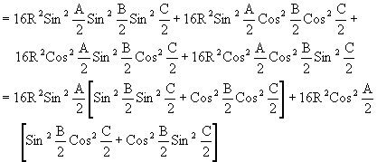
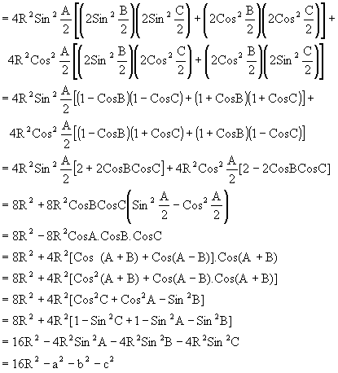
= R.H.S.
Q-7: Solve 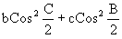 in terms of K where K is perimeter of Δ ABC.
Solution:
Here,
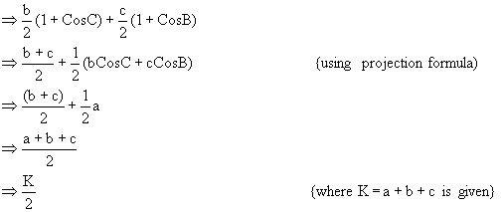

Q-8: Find the sides and angles of the pedal triangle.
Solution:

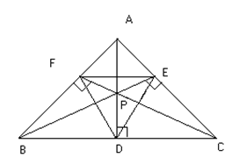
Fig (19)
Since the angle PDC and PEC are right angles, the points P, E, C and D lie on a circle.
∴∠PDE = ∠PCE = 90-A
Similarly P, D, B and F lie on a circle and therefore
∠PDF = ∠PBF = 90-A
Hence ∠FDE = 180-2A
Similarly ∠PEF = 180-2B
∠EFD = 180-2C
Also from triangle AEF we have
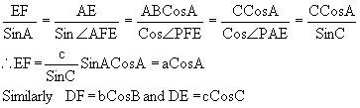

Q-9: Prove that in a ΔABC
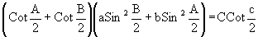
Solution:
L.H.S = 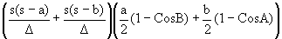
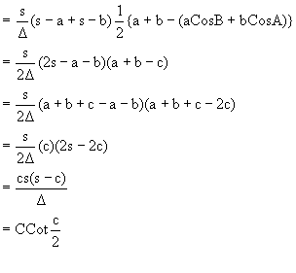
Q-10: Find the radii of the inscribed and the circumscribed circle of a regular polygon of n side
with each side and also find the area of the regular polygon.
Solution:
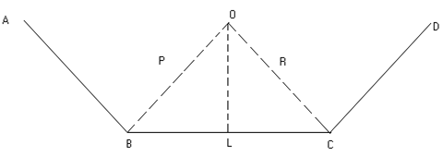
Fig (20)
Let AB, BC and CD be three successive sides of the polygon and O be the center of both
the incircle and the circumcircle of the
polygon.
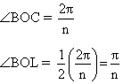
If a be a side of the polygon, we have a=BC=2BL=2RSinBOL = 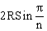
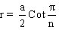
Now the area of the regular polygon = n times the area of the ΔOBC
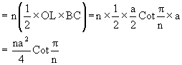

Q-11: If a₁b and A are given in a triangle and c₁, c₂ are the possible values of the third side,
prove that
Solution:
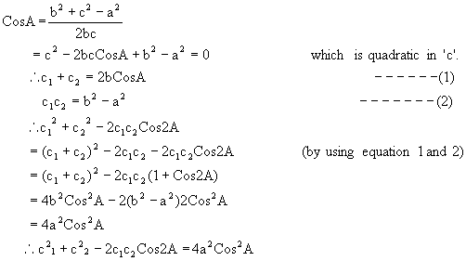
Q-12: Prove that in a triangle the sum of exradii exceeds the inradius by twice the diameter of
the circumcircle.or prove that r₁+r₂+r₃ = r+4R.
Solution: Let the exradii be r_{1,} r_{2,} r₃ and inradius = r, circum radius = R.
Then we have to prove that r₁+r₂+r₃ = r+4R.
Now,
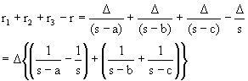
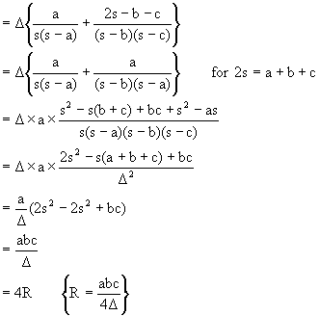
Medium
Q-1:
In a ΔABC the angles A, B, C are in A.P show that 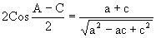
Solution:
Here, A, B, C are in A.P So B=A-α; C=A-2α
Also
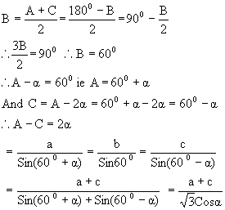

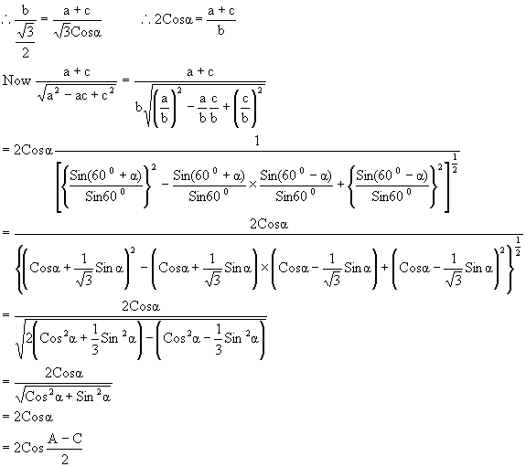

Q-2: If in a ΔABC, CosA.CosB+SinA.SinB.SinC = 1, Show that a: b: c = 1:1:√2
Solution: Given relation yields,
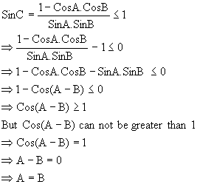
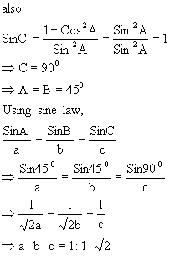
Hard
Q-1: The internal bisectors of the angles of the ΔABC meet the sides BC, CA and AB at P, Q, and R respectively. Show that the area of the ΔPQR is equal to 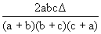
Solution:
Let the bisector of the angles meet at I. then I is the incenter. Let ID⊥BC, then ID = inradius = r.
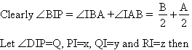
Q=∠BIP-∠BID = 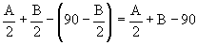
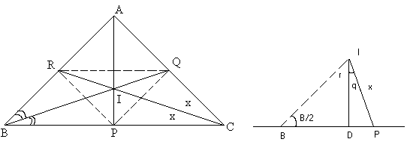
Fig (24)
Now from ΔDIP, 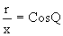
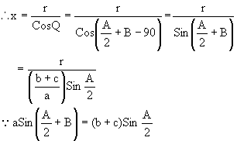

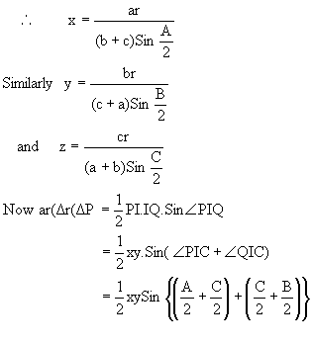
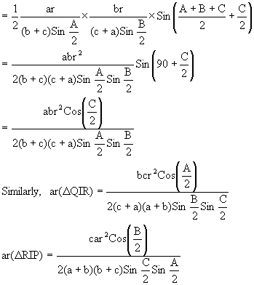

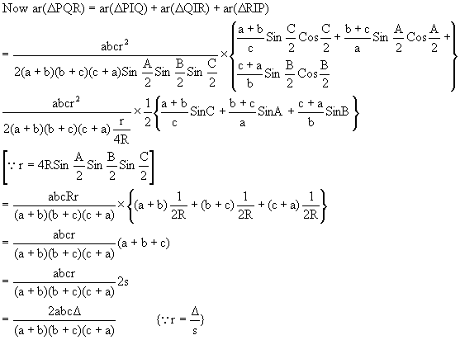

Q-2: Show that the ΔABC is equilateral if its circumradius is double of the inradius.
Solution:
Here R=2r (given) .We know that,
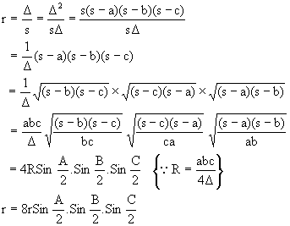
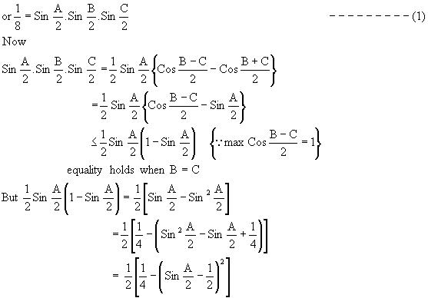
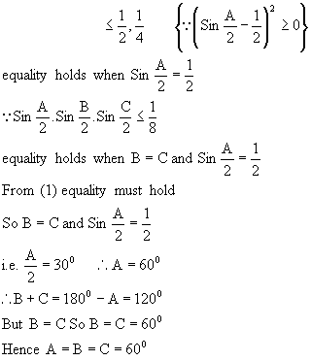
So, triangle is equilateral.

